DATABASE SYSTEMS ENGINEERING AND DISTRIBUTED BACKEND DEVELOPMENT

WEEK – 1

2520030159 – B. HEMA SRI

Step 1 — Create Database:

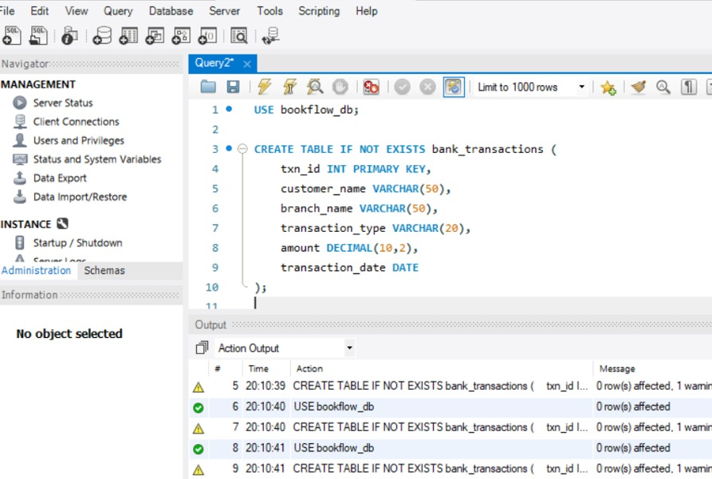

Step 2 — Create Books Table (DDL + Constraints)

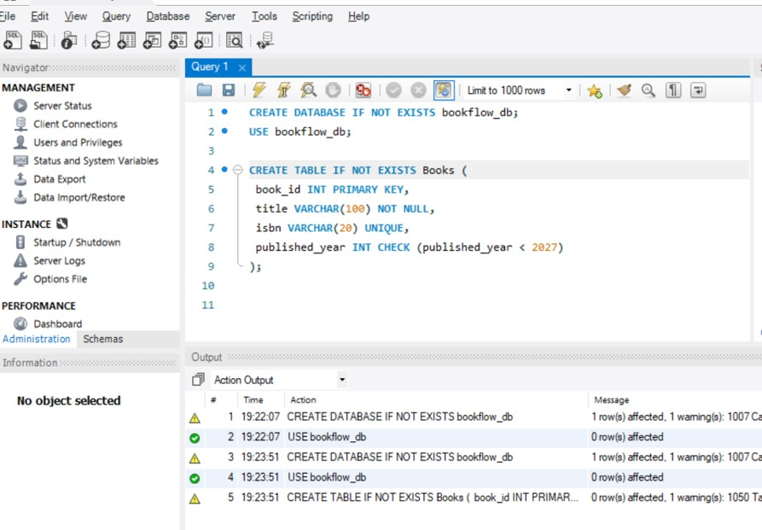

Step 3 & 4 — Insert Books and Display:
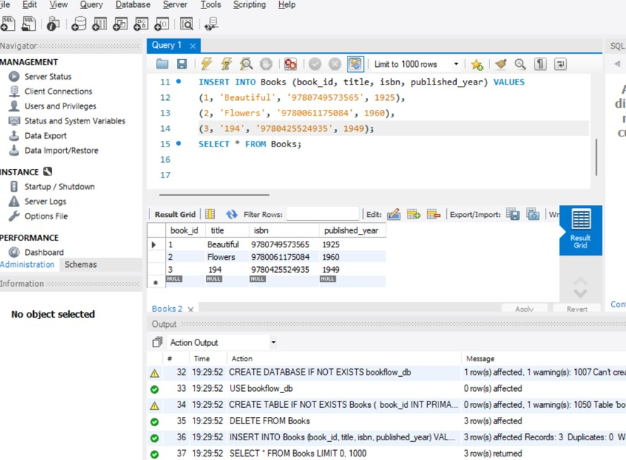

Step 5, 6 & 7 — Members Table: Create, Insert, Display:

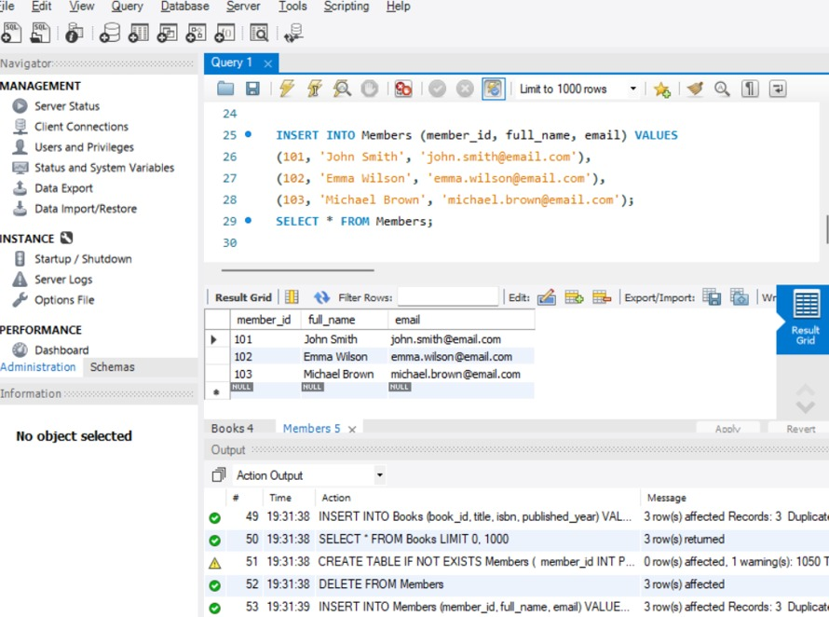

Step 8 — Create Loans Table (FOREIGN KEYS):

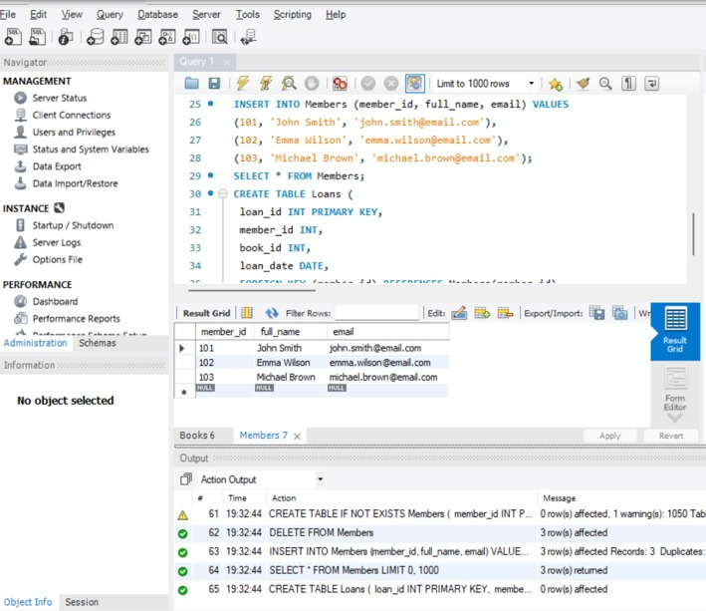

Step 9 & 10 — Insert 10 Loans and Display:

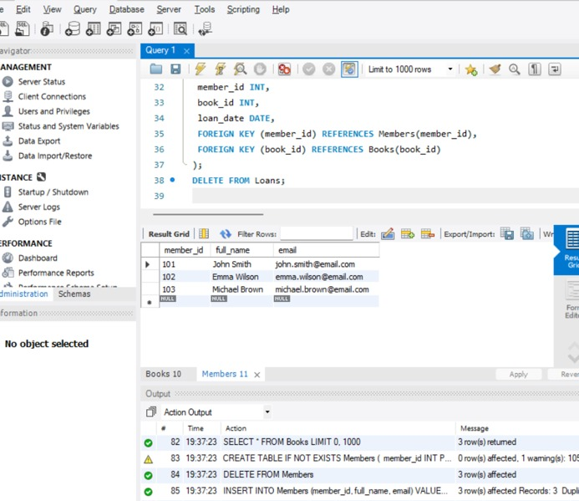

Step 11 — JOIN Query (Who Borrowed What):

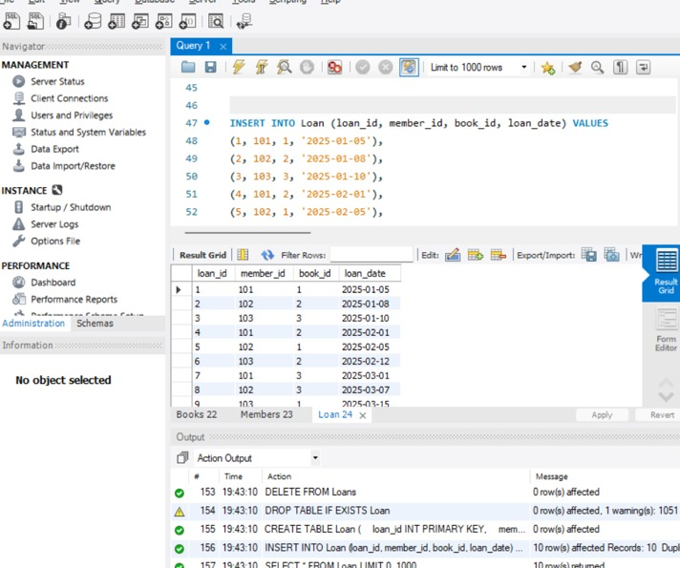

Step 12 — GROUP BY Query (Books per Year):

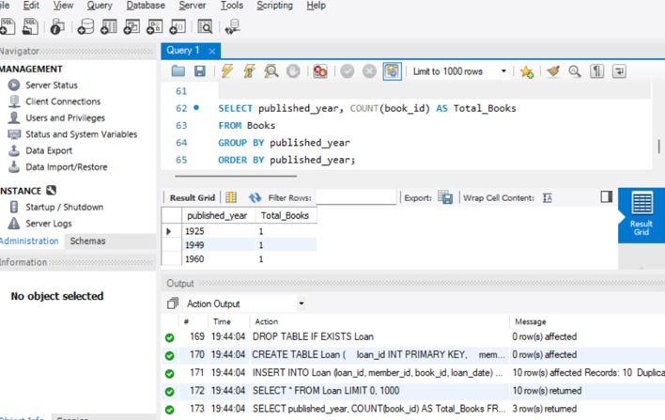

Step 13–16 — Donation via TRANSACTION (Atomicity):

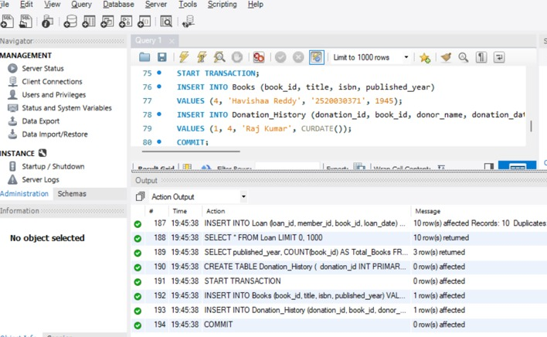

Step 17 & 18 — Index on ISBN + Fast Search:

